**Harsh Vardhan Kushwaha**

**17BCN7017**

**Exercise 8**

1. Write a PL/SQL block to find the greatest of three numbers.

Code –

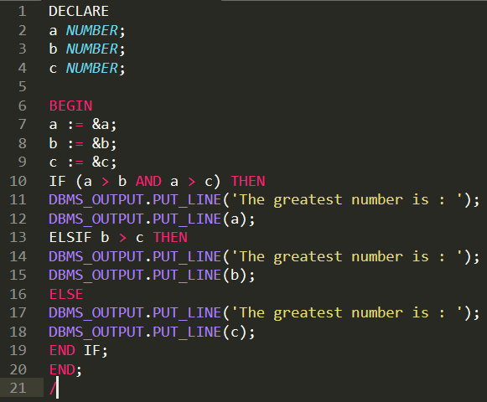

Output –

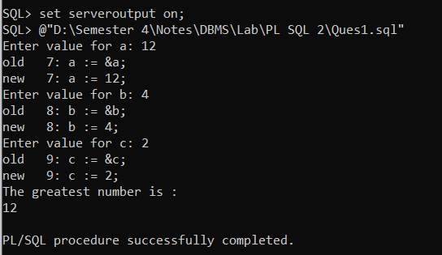

1. Write a PL/SQL code to print the student’s grade accepting their marks in three subjects.\

Code –

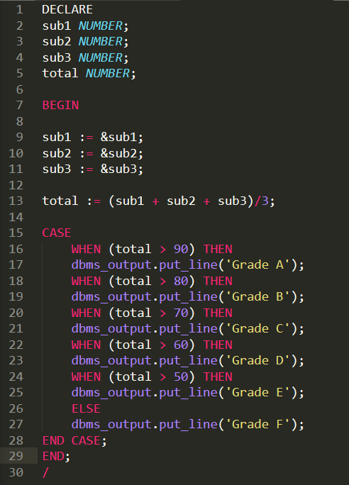

Output –

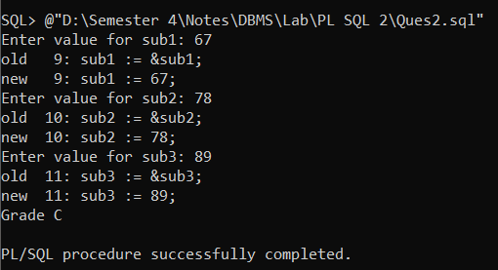

1. Write a PL/SQL block to reverse a number.

Code –

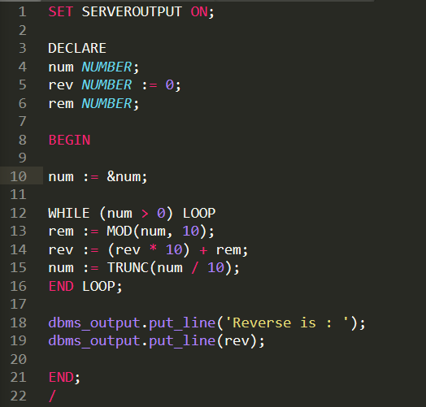

Output –

